
Project Title: Smart Food-Waste Redistribution Platform

By

Mubarak Al-Ali
Humaid Alsereidi
Zayed Alshehhi

A Project Presented to SWE 401: Software Engineering
CSIT Department
College of Engineering
Abu Dhabi University

Instructor: Dr. Murad Al-Rajab

Abu Dhabi, United Arab Emirates

Fall 2026
Submission Date: September 24, 2026

1. Project Description
1.1 Introduction and Problem Definition
Food waste is a major issue for businesses and communities. Restaurants and stores often have safe food left near closing time. However, available surplus is not always identified early. Therefore, suitable recipients often receive information too late. This creates delays in donation and collection activities. It also increases the amount of usable food discarded. The proposed project addresses this problem through one digital platform. The system connects food providers with charities and buyers. It also uses historical information to predict future surplus.
1.2 General System Overview
The proposed system manages surplus food from initial prediction. First, businesses provide information about sales and available food. The system then analyzes previous records and operating patterns. Based on these records, it predicts possible surplus quantities. Businesses receive alerts before expected surplus becomes available. They then confirm the available food through the platform. The system identifies suitable charities or discounted buyers. It also considers quantity, food type, location, and collection time. Finally, pickup information is recorded for later reporting.
1.3 Main System Functions
The system will provide three main functions. First, predictive surplus alerts will estimate expected surplus. Second, smart matching will connect food with suitable recipients. Third, route planning will support organized pickup arrangements. The platform will also record redistribution activities and outcomes. These records will support impact and compliance reporting.
1.4 Stakeholders and Intended Users
Food businesses will use the system to manage surplus. Charities will receive information about suitable available food. Discounted buyers will access eligible surplus before disposal. Drivers or volunteers will receive pickup information through the platform. Administrators will manage users, records, and system activities. Each user group will receive functions related to its responsibilities. Therefore, access permissions will differ between the user groups.

1.5 Current System
The current process often begins after surplus food appears. Business employees first identify the remaining food manually. They then contact charities or potential buyers for collection. The recipient checks the food type and available quantity. Afterward, both parties arrange a suitable collection time. Drivers or volunteers then collect and deliver the food. Records are often maintained through separate communication channels. This process provides limited prediction before surplus food appears.
1.6 Key Problems and Development Challenges
The first problem concerns late identification of surplus food. The second problem concerns manual recipient selection and communication. The third problem concerns inefficient pickup coordination between locations. Another challenge involves obtaining suitable historical data for prediction. Prediction accuracy will also depend on data quality. Food safety information must remain accurate throughout each transaction. Location information also requires appropriate access controls and protection.
1.7 Ethical, Privacy, Security, and Societal Considerations
The system will collect business and user information. Therefore, access will be limited according to user roles. Authentication will protect accounts from unauthorized access. Location information will only support required pickup activities. Food safety information will require accurate records from businesses. The prediction model will also require performance monitoring. This helps identify differences in prediction quality across businesses. The interface will use simple controls for accessibility. The system will also support responsible redistribution practices.
2.8 Technologies
The proposed platform will use React for the web interface. Node.js will support backend application services. PostgreSQL will store users and transaction records. Python will support the predictive analysis component. Scikit-learn will support development of the prediction model. GitHub will manage source code and team contributions. A mapping service will support location and route information. The final technology choices will follow implementation requirements.

2.9 Team Members
2.9.1 Mubarak Al-Ali
Mubarak Al-Ali will participate in requirements analysis activities. He will also support system documentation and testing activities.
2.9.2 Humaid Alsereidi
Humaid Alsereidi will participate in frontend development activities. He will also support interface design and usability testing.
2.9.3 Zayed Alshehhi
Zayed Alshehhi will participate in backend development activities. He will also support database development and system integration.

2. Market Potential
2.1 User Interest
Food businesses need practical methods for managing surplus. The proposed system reduces repeated communication between different users. Businesses receive earlier information about expected surplus quantities. Charities receive information about available food through one platform. Buyers also receive information about eligible discounted food. Therefore, each user receives functions related to their needs.
2.2 Social and Environmental Impact
Food redistribution can reduce unnecessary disposal of usable food. It also supports organizations that provide food assistance. The platform will record quantities redistributed through completed transactions. These records provide information about the system's social impact. Businesses can also review their redistribution activities over time. However, food safety requirements must remain part of every transaction.
2.3 Similar Systems
Existing food-rescue platforms already support surplus food redistribution. Some systems focus on discounted sales for consumers. Other platforms focus on connecting businesses with charities. These systems demonstrate demand for digital food redistribution services. However, the proposed system focuses on predicting surplus earlier. It also combines prediction with recipient matching and pickup planning. The team will verify each existing system through reliable sources.
2.4 Benchmark Comparison
System | Main Function | Strength | Limitation | Proposed Improvement
Existing Platform 1 | Surplus food redistribution | Connects food providers with recipients | Limited prediction | Add surplus forecasting
Existing Platform 2 | Discounted surplus sales | Helps businesses sell surplus | Focuses mainly on consumers | Add charity matching
Existing Platform 3 | Food donation coordination | Supports donation activities | Limited route planning | Add pickup coordination
Proposed Platform | Prediction, matching, routing, tracking | Integrates several functions | Requires suitable project data | Develop integrated workflow

2.5 Novelty of the Proposed Idea
The proposed system focuses on identifying surplus before disposal. Historical business information will support future surplus predictions. The prediction will then connect with recipient matching functions. Pickup planning will support timely collection after confirmation. The platform will also maintain records of redistribution outcomes. This combination forms the main functional difference of the proposed system.

3. Project Management Plan
3.1 Activities and Sequence
The project will begin with background research and problem analysis. The team will then identify system stakeholders and requirements. Afterward, functional and non-functional requirements will be documented. UML models will then describe the proposed system structure. Database and interface designs will follow the analysis activities. Development will begin after the main designs are completed. Testing will then evaluate the implemented system functions. Finally, the team will prepare documentation and presentation materials.
3.2 Software Project Methodology
The project will follow an Agile development methodology. The team will divide development into manageable activities. Each iteration will focus on selected system functions. Requirements will be reviewed during the development process. Problems will therefore be identified before final integration. The team will also use GitHub for source control. This approach supports regular contributions from all team members.
3.3 Workplan
Activity | Sequence | Main Output
Background Research | 1 | Problem evidence
Requirements Analysis | 2 | Requirements
Use Case Analysis | 3 | Use Case Model
System Analysis | 4 | UML Models
Database Design | 5 | Database Model
Interface Design | 6 | UI Mockups
Backend Development | 7 | Backend Services
Frontend Development | 8 | User Interface
Prediction Module | 9 | Prediction Function
System Integration | 10 | Integrated System
Testing | 11 | Test Results
Documentation | 12 | Final Report
Presentation | 13 | Project Presentation
3.4 Gantt Chart
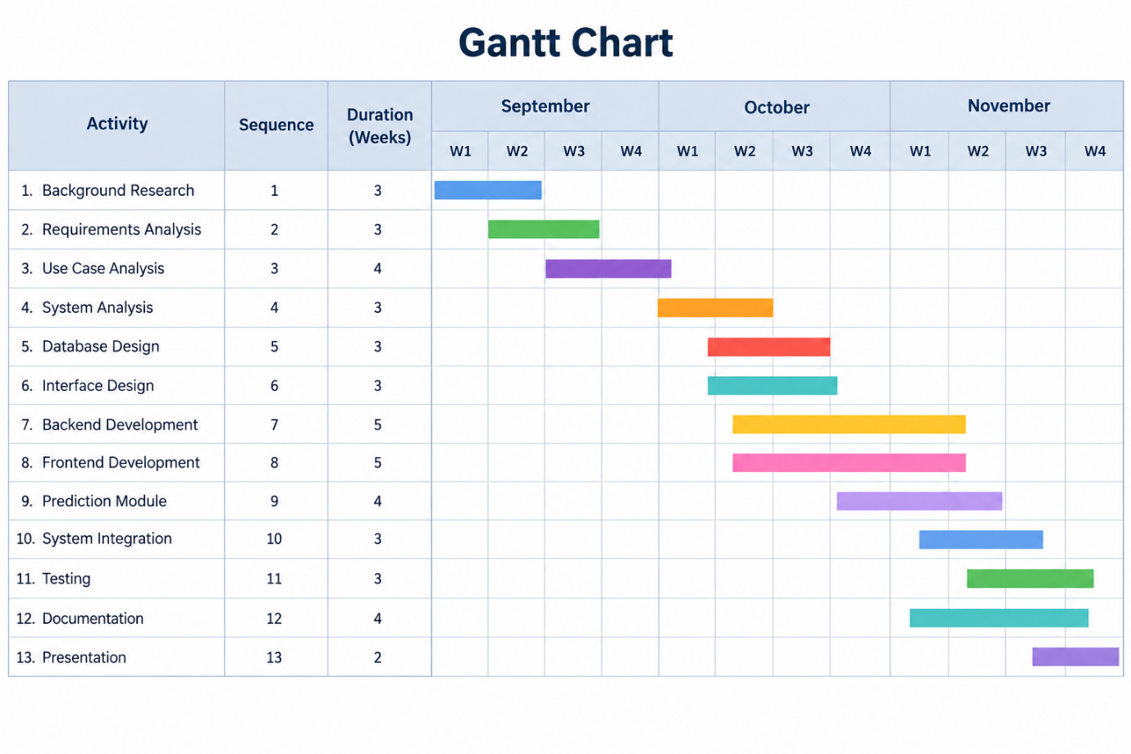
3.5 Budget
The project will initially rely on available development resources. Open-source programming tools will support software development activities. GitHub will support source-code management and team collaboration. Development will use existing computers and available internet connections. The estimated hosting cost is AED 110, while mapping services are estimated at AED 75. A domain name is estimated at AED 55, giving a total estimated budget of AED 240.

4. Project Repository
The project will use GitHub for source-code management. All three students will be added as repository collaborators. Each member will contribute through individual commits. The repository will contain source code, documentation, and project files. The team will maintain a clear commit history throughout development.
GITHUB LINKS: https://github.com/mubarak-1089967
https://github.com/1092803
https://github.com/1091367

